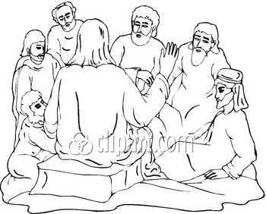

Luke 12:13-21 4th-5th Grade Class
Key verse: 15 Name: __________

Write and memorize the key verse.

____________________________________________________________________________________________________________________________________________________________________________________________________



1. What was Jesus doing? (Luke 12:1a) During that time a crowd of many thousands had gathered. There were so many people that they were stepping on one another. Jesus spoke first to his disciples.
____________________________________________________________________________________________________________________________________________________________________________________________________

2. Who interrupted Jesus and why? (13) Someone in the crowd spoke to Jesus. "Teacher," he said, "tell my brother to divide the family property with me."

____________________________________________________________________________________________________________________________________________________________________________________________________

3. What did Jesus say to the man and why? (14) Jesus replied, "Friend, who made me a judge or umpire between you?"

____________________________________________________________________________________________________________________________________________________________________________________________________

4. What is greed and why did Jesus warn his disciples about it? (15) Then he said to them, "Watch out! Be on your guard against wanting to have more and more things. Life is not made up of how much a person has."

____________________________________________________________________________________________________________________________________________________________________________________________________

5. How do you struggle with greed?
____________________________________________________________________________________________________________________________________________________________________________________________________

6. How can you overcome and guard against greed? (Proverbs 30:8-9) Keep lies far away from me. Don't make me either poor or rich, but give me only the bread I need each day. 9 If you don't, I might have too much. Then I might say I don't know you. I might say, 'Who is the Lord?' Or I might become poor and steal. Then I would bring shame to the name of my God.

___________________________________________________________________________________________________________________________________________________
_________________________________________________

7. What story did Jesus tell his disciples? (16-17) Then Jesus told them a story. He said, "A certain rich man's land produced a good crop. 17 He thought to himself, 'What should I do? I don't have any place to store my crops.'

____________________________________________________________________________________________________________________________________________________________________________________________________

8. Why did the man want to build bigger barns? (18) "Then he said, 'This is what I'll do. I will tear down my storerooms and build bigger ones. I will store all my grain and my other things in them.

____________________________________________________________________________________________________________________________________________________________________________________________________

9. What did the man plan to do with the rest of his life? (19) I'll say to myself, "You have plenty of good things stored away for many years. Take life easy. Eat, drink and have a good time." '

____________________________________________________________________________________________________________________________________________________________________________________________________

10. What did God call this man and why? (20) "But God said to him, 'You foolish man! This very night I will take your life away from you. Then who will get what you have prepared for yourself?'
____________________________________________________________________________________________________________________________________________________________________________________________________

11. What will happen to all who live like this man? (21) "That is how it will be for anyone who stores things away for himself but is not rich in God's eyes."
____________________________________________________________________________________________________________________________________________________________________________________________________

12. How can you be rich toward God?

____________________________________________________________________________________________________________________________________________________________________________________________________

__________________________________________________________________________________________________________________________________________________________________________________________________________________________________________________________________________________________________________________________________________________________________________________________________________________________________________________________________________________________________________________________________________________________________________________________________________________________________________________________________________________________________________________________________________________________________________________________________________________________________________________________________________________________________________________________________________________________________________________________________________________________________________________________________________________________________________________________________________________________________________________________________________________________________________________________________________________________________________________________

