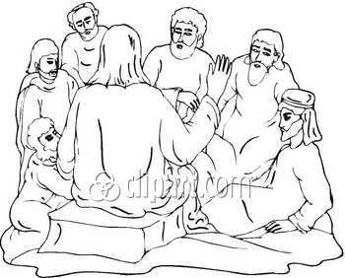

Luke 12:13-21 2nd-3rd Grade Class
Key verse: 15 Name: __________

Write and memorize the key verse.

____________________________________________________________________________________________________________________________________________________________________________________________________

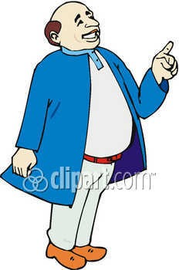

1. What was Jesus doing? (Luke 12:1a) During that time a crowd of many thousands had gathered. There were so many people that they were stepping on one another. Jesus spoke first to his disciples.
A. Jesus was speaking to the crowds that had gathered B. Jesus was speaking to a man that had questioned him C. Jesus was speaking to his disciples D. None of the answers are correct
2. Who interrupted Jesus? (13) Someone in the crowd spoke to Jesus. "Teacher," he said, "tell my brother to divide the family property with me."

A. A greedy man in the crowd interrupted Jesus’ teaching B. A sinful woman came and poured perfume on Jesus’ feet C. A man with many demons interrupted Jesus’ teaching D. None of the answers are correct

3. What did Jesus say to the man and why? (14) Jesus replied, "Friend, who made me a judge or umpire between you?"

____________________________________________________________________________________________________________________________________________________________________________________________________

4. What is greed and why did Jesus warn his disciples about it? (15) Then he said to them, "Watch out! Be on your guard against wanting to have more and more things. Life is not made up of how much a person has."

____________________________________________________________________________________________________________________________________________________________________________________________________

5. What story did Jesus tell his disciples? (16-17) Then Jesus told them a story. He said, "A certain rich man's land produced a good crop. 17 He thought to himself, 'What should I do? I don't have any place to store my crops.'

A. The story of rich fool B. The story of the poor fool C. The story of the boy who cried wolf D. None of the answers are correct

6. Why did the man want to build bigger barns? (18) "Then he said, 'This is what I'll do. I will tear down my storerooms and build bigger ones. I will store all my grain and my other things in them.

____________________________________________________________________________________________________________________________________________________________________________________________________

7. Read the verse and fill in the blanks. (19) And I’ll say to myself, “You have ____________ of _________ _______ stored away for ______ years. Take life _____. _____, ______ and ____________ .”’

8. What did God call this man and why? (20) "But God said to him, 'You foolish man! This very night I will take your life away from you. Then who will get what you have prepared for yourself?'
A. God called this man a fool B. Fools live like there is no God and no judgment C. Fools only live for themselves D. All the answers are correct

9. What will happen to all who live like this man? (21) "That is how it will be for anyone who stores things away for himself but is not rich in God's eyes."

____________________________________________________________________________________________________________________________________________________________________________________________________

_______________________________________________________________________________________________________________________________________________________________________________________________________________________________________________________________________________________________________________________________________________________________________________________________________________________________________________________________________________________________________________________________________________________________________________________________________________________________________________________________________________________________________________________________________________________________

